

**TITLE: -** College Feedback Classifier

**NAME: -** K. Sri Anjani

**Roll NO: -** 23BCE20001

**College Name: -** Vellore Institute of Technology (VIT), Amaravati

**Branch: -** Computer science and Engineering

**Date of Submission: -** 03-07-2025

**Table of Content**

|  |  |  |
| --- | --- | --- |
| S.NO | Topic | Page.NO. |
| 1. | Introduction | 3 |
| 2. | Objectives | 3 |
| 3. | Tools | 3 |
| 4. | Methodology | 4 |
| 5. | Code snippets | 5-12 |
| 6. | GitHub link | 13 |
| 7. | Conclusion | 13 |

**1. INTRODUCTION**

Feedback from students plays a vital role in improving the academic and administrative functions of any educational institution. However, manually categorizing open-ended feedback can be inefficient and inconsistent. The **College Feedback Classifier** is an AI-powered system that automates this process.

This project uses few-shot prompting techniques with IBM watsonx.ai foundation models to classify free-text feedback into meaningful categories like *Academics*, *Facilities*, or *Administration*. It enables academic institutions to identify key strengths and problem areas based on student input.

**2. OBJECTIVES**

* To automate the classification of textual student feedback.
* To map feedback into high-level themes for easier analysis.
* To generate structured summaries and reports.
* To support data-driven decision-making for institutional improvement.

**3. TOOLS**

|  |  |
| --- | --- |
| Category | Tools/Technologies |
| Programming Language | Python |
| Libraries | pandas, sklearn, IBM WML SDK |
| AI Model | FLAN-T5 / Mistral |
| Platform | IBM watsonx.ai |
| Cloud Storage | IBM Cloud Object Storage (COS) |
| IDEs | Google Colab |

**4. Methodology:**

1. **Data Preparation**  
A dataset of student feedback is collected in CSV format. Each row contains free-text feedback and optionally a manually assigned category.

2. **Prompt Engineering**  
Few-shot examples are provided to the model, showing how feedback should be mapped to categories.

3. **Model Setup**  
IBM watsonx.ai foundation models such as flan-t5-xxl are initialized using project credentials.

4. **Classification**  
Each feedback entry is passed through the prompt for classification into a relevant category.

5. **Evaluation**  
The predicted categories are compared with ground truth labels to assess accuracy.

6. **Export**  
Results are saved to a CSV for further reporting and analysis.

**5. Code Snippets**

**Importing Required Libraries**

This block imports required libraries for data manipulation, model integration, and performance evaluation.

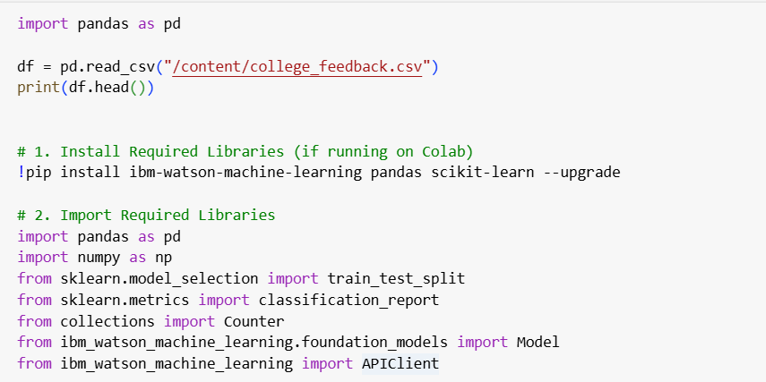



**IBM Credentials Setup**

This initializes the IBM Watson Machine Learning client and connects it to your cloud project.

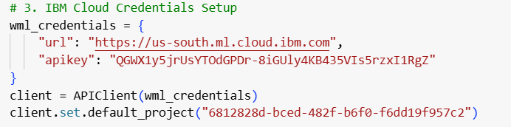



**Dataset Loading**

Loads the CSV containing student feedback and removes any empty rows.

**Few-shot Prompt Setup**

Provides example feedbacks and their correct categories to guide the model during classification (few-shot prompting).

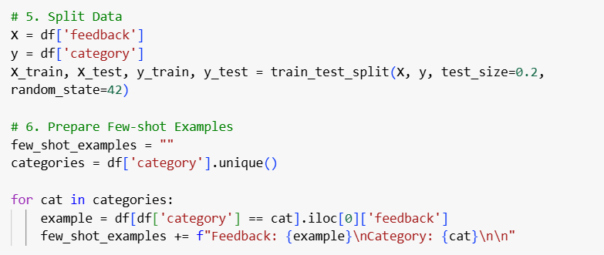

**Initialize Foundation Model**

Initializes the FLAN-T5 model for classification with specified parameters and credentials.

**Define Classification Function**

Uses the prompt and user input to predict the category of feedback using the model. Also includes basic error handling*.*

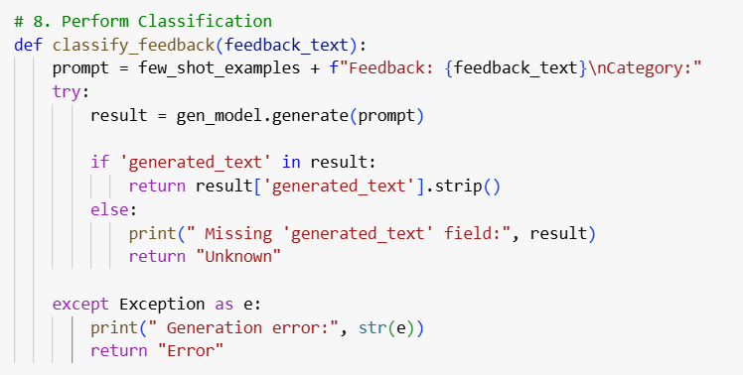

**Run Classification on Feedback Data**

Applies the model classification function to every feedback entry in the dataset*.*

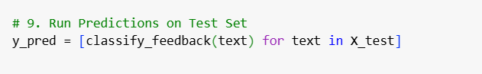

**Export the Results**

Saves the predicted results to a new CSV file for review or submission.

**6. GitHub link**

**7. Conclusion**

The **College Feedback Classifier** project successfully automates the task of categorizing student feedback using advanced foundation models. It replaces time-consuming manual processes with AI-powered classification, making it easier for college administrators to identify strengths and issues across academic, administrative, and facility domains. The use of IBM watsonx.ai ensures highly relevant and context-aware predictions. This system can be further extended to real-time dashboards and alert systems in future versions.